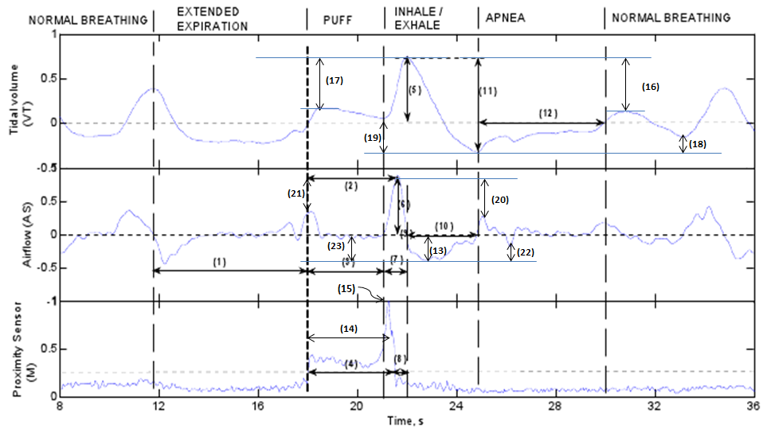

New Added Feature List:

Feature # 15: Maximum value of Proximity Sensor.

Feature # 16: Peak of VT – peak of next VT.

Feature # 17: Peak of VT – previous peak of VT.

Feature # 18: Valley of VT – next valley of VT.

Feature # 19: Valley of VT – previous valley of VT.

Feature # 20: Peak of AS – next peak of AS.

Feature # 21: Peak of AS – previous peak of AS.

Feature # 22: Valley of AS – next valley of AS.

Feature # 23: Valley of AS – previous valley of AS.

Feature # 24: **L2 norm** of **exhale** part of **AS** – L2 of **next** exhale part of AS.

Feature # 25: **L2 norm** of **exhale** part of **VT** – L2 of **next** exhale part of VT.

Feature # 26: **L2 norm** of **inhale** part of **AS** – L2 of **next** inhale part of AS.

Feature # 27: **L2 norm** of **inhale** part of **VT** – L2 of **next** inhale part of VT.

Feature # 28: Peak of VT – peak of **2nd next** VT.

Feature # 29: Peak of VT – peak of **3rd next** VT.

Feature # 30: Peak of VT – **previous 2nd** peak of VT.

Feature # 31: Peak of VT – **previous 3rd** peak of VT.

Feature # 32: Valley of VT – **2nd next** valley of VT.

Feature # 33: Valley of VT – **3rd next** valley of VT.

Feature # 34: Valley of VT – **2nd previous** valley of VT.

Feature # 35: Valley of VT – **3rd previous** valley of VT.

Feature # 36: Peak of AS – **2nd next** peak of AS.

Feature # 37: Peak of AS – **3rd next** peak of AS.

Feature # 38: Peak of AS – **2nd previous** peak of AS.

Feature # 39: Peak of AS – **3rd** **previous** peak of AS.

Feature # 40: Valley of AS – **2nd next** valley of AS.

Feature # 41: Valley of AS – **3rd next** valley of AS.

Feature # 42: Valley of AS – **2nd previous** valley of AS.

Feature # 43: Valley of AS – **3rd previous** valley of AS.

Feature # 44: **L2 norm** of **exhale** part of **AS** – L2 of **2nd** **next** exhale part of AS.

Feature # 45: **L2 norm** of **exhale** part of **AS** – L2 of **3rd** **next** exhale part of AS.

Feature # 46: **L2 norm** of **exhale** part of **AS** – L2 of **2nd** **previous** exhale part of AS.

Feature # 47: **L2 norm** of **exhale** part of **AS** – L2 of **3rd** **previous** exhale part of AS.

Feature # 48: **L2 norm** of **exhale** part of **VT** – L2 of **2nd** **next** exhale part of VT.

Feature # 49: **L2 norm** of **exhale** part of **VT** – L2 of **3rd next** exhale part of VT.

Feature # 50: **L2 norm** of **exhale** part of **VT** – L2 of **2nd previous** exhale part of VT.

Feature # 51: **L2 norm** of **exhale** part of **VT** – L2 of **3rd previous** exhale part of VT.

Feature # 52: **L2 norm** of **inhale** part of **AS** – L2 of **2nd next** inhale part of AS.

Feature # 53: **L2 norm** of **inhale** part of **AS** – L2 of **3rd** **next** inhale part of AS.

Feature # 54: **L2 norm** of **inhale** part of **AS** – L2 of **2nd previous** inhale part of AS.

Feature # 55: **L2 norm** of **inhale** part of **AS** – L2 of **3rd previous** inhale part of AS.

Feature # 56: **L2 norm** of **inhale** part of **VT** – L2 of **2nd next** inhale part of VT.

Feature # 57: **L2 norm** of **inhale** part of **VT** – L2 of **3rd next** inhale part of VT.

Feature # 58: **L2 norm** of **inhale** part of **VT** – L2 of **2nd previous** inhale part of VT.

Feature # 59: **L2 norm** of **inhale** part of **VT** – L2 of **3rd previous** inhale part of VT.